F0/1

F0/9

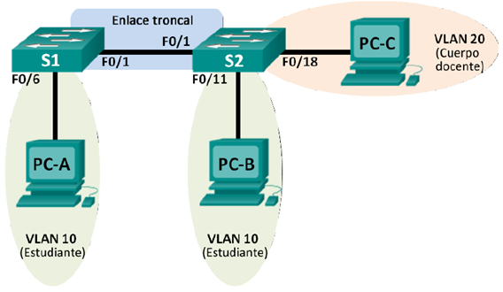

R1(config)#interface fastethernet 0/1

R1(config-if)#no shutdown

R1(config-if)#interface fastethernet 0/1.1

R1(config-subif)#encapsulation dot1q 1

R1(config-subif)#ip address 192.168.1.1 255.255.255.0

R1(config-if)#interface fastethernet 0/1.10

R1(config-subif)#encapsulation dot1q 10

R1(config-subif)#ip address 192.168.10.1 255.255.255.0

R1(config-if)#interface fastethernet 0/1.20

R1(config-subif)#encapsulation dot1q 20

R1(config-subif)#ip address 192.168.20.1 255.255.255.0

R1(config-if)#interface fastethernet 0/1.99

R1(config-subif)#encapsulation dot1q 99 native

R1(config-subif)#ip address 192.168.99.1 255.255.255.0